- Install PyCharm Community Edition
  - Downlink Link
    - For Windows : https://www.jetbrains.com/pycharm/download/?section=windows
    - For Mac : https://www.jetbrains.com/pycharm/download/?section=mac
  - Download any latest or preferable version 2023.2.2
  - During installation, ensure to select below mentioned checkboxes
  - 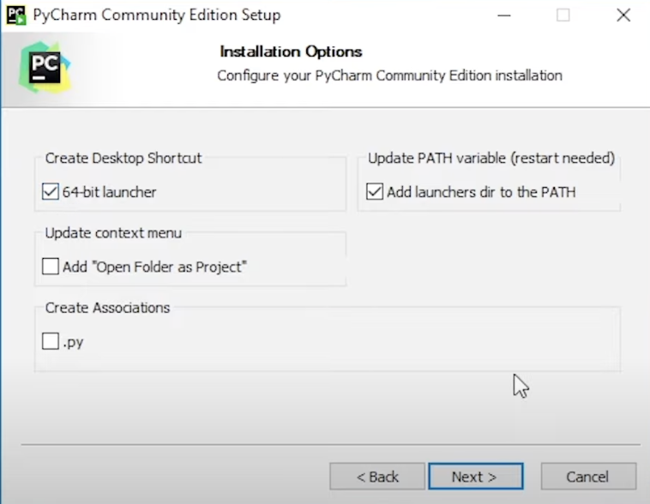
- Create Python Virtual Environment
  - Goto PyCharm Terminal: pip3 install virtualenv
  - Create new folder and goto this new folder using PyCharm terminal using “cd” command
  - virtualenv myvirtualenv or python -m venv <new_folder_path>
  - source <new_folder_path>/bin/activate
  - virtualenv --version
- Install Python v3.12.0
  - Preferable way: Open PyCharm Terminal -> Ensure Virtual Env is activated as above → pip3 install python
  - Manual Downloader For Windows: https://www.python.org/downloads/release/python-3120/
  - Manual Downloader For Mac:
    - Download Homebrew first: /bin/bash -c "$(curl -fsSL https://raw.githubusercontent.com/Homebrew/install/HEAD/install.sh)"
    - In Terminal run command: brew install python
  - Confirm installation using running command “python3 --version” in Terminal or CMD

- Install Java v11.0.24
  - Download URL : https://www.oracle.com/java/technologies/downloads/
  - Set JAVA_HOME path in Environment Variables→System Variables
  - Add Java to System Path
  - Ensure Java installed correctly using “java --version” command in terminal / cmd
- Install Selenium ChromeDrivers
  - Download URL: https://chromedriver.storage.googleapis.com/index.html?path=114.0.5735.90/
  - Save this ChromeDriver to your harddisk --> Create new text/notepad file on desktop named 'MyChromDriverPath' --> Save this above steps downloaded ChromeDriver file path into this notepad file.
- Install Chromium (Test Automation Browser)
  - For Windows 64-bit Laptop: https://storage.googleapis.com/chrome-for-testing-public/128.0.6613.119/win64/chrome-win64.zip
  - For Windows 32-bit Laptop: https://storage.googleapis.com/chrome-for-testing-public/128.0.6613.119/win32/chrome-win32.zip
  - For MacOS Laptop: https://storage.googleapis.com/chrome-for-testing-public/128.0.6613.119/mac-x64/chrome-mac-x64.zip

- Install Chrome Browser v114.xxx
  - Download URL: https://chrome.softwaredownload.co.in/chrome-114-0-5735-91

- Install SelectorsHub Chrome Browser Extension
  - Download URL: https://selectorshub.com/selectorshub/
  - On above URL, click on "Add to Chrome -its free" button
  - Close your chrome browser and start again

